STB_TE Hydrogen Pul

Hydrogen – clean energy (carrier)

I Watch the video on hydrogen and answer the following questions.
https://www.youtube.com/watch?v=8Mi32tnyvQs (2022)

1 What are advantages of using hydrogen? List two.

2 Which applications are mentioned?

3 Where does hydrogen occur?

4 Which colors is hydrogen often being referred to?

5 What does the given color in general depend on? Give examples, please.

6 What are the two disadvantages of electrolysis?

7 What is a more common method of creating hydrogen gas compared to electrolysis?

II Pair work: Work on one of the following tasks. Take notes, present your results to your partner.

1 Explain the COLOUR SPECTRUM of hydrogen in detail and draw a conclusion on environmentally-friendly technological solutions.
https://www.nationalgrid.com/stories/energy-explained/hydrogen-colour-spectrum (2022)

2 What is GOLDEN HYDROGEN? Explain this source of carbon neutral hydrogen and draw a conclusion in how far it meets innovation and collaboration.
https://www.goldhydrogen.com/ (2022)

STB_TE Hydrogen - Solutions Pul

Hydrogen – clean energy (carrier)

Watch the video on hydrogen and answer the following questions.
https://www.youtube.com/watch?v=8Mi32tnyvQs (2022)

1 What are advantages of using hydrogen? List two.

  - It can be burned for clean energy, when hydrogen reacts with oxygen to produce energy the only waste product is water.
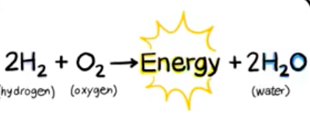
1.2 It can be used to store renewable energy to improve the flexibility of power grid. It is an energy carrier which is used to store and move energy.

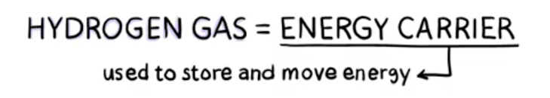

2 Which applications are mentioned?

In transportation, hydrogen can be used in fuel cells in cars and other vehicles.

3 Where does hydrogen come from?

It is the most abundant element in the universe. On earth it is not available as a pure gas but combined with other elements like carbon in methane or oxygen in water. You need to separate them from the other elements. We need energy for that like heat or electricity.

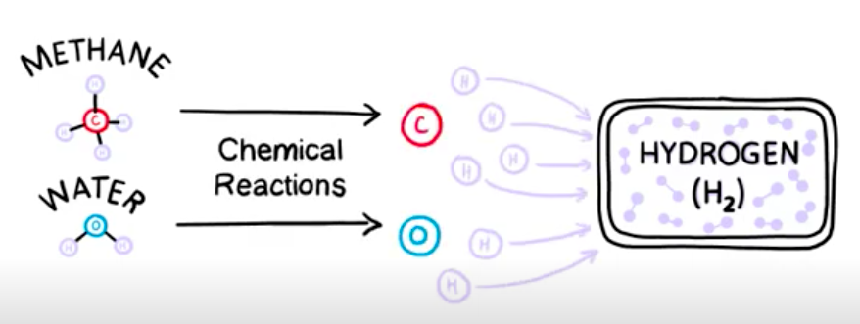 | 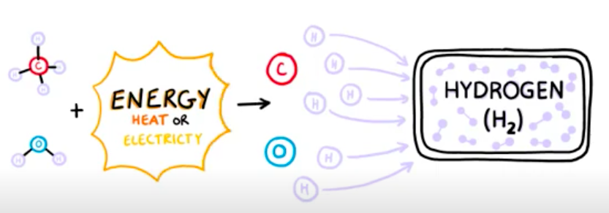

4 Which colors is hydrogen often being referred to?

Yellow, green, blue, pink, turquoise, grey, brown or black hydrogen and even gold…

5 What does the given color in general depend on? Give examples, please.

It depends on the method used to create it. E.g. if you use fossil fuels or coal to create energy to make hydrogen gas, this is referred to as brown or black hydrogen.
If it is produced in an environmentally-friendly way it is called green hydrogen.
Green hydrogen is created through a process called electrolysis, which passes an electric current through water to split H2O molecules into hydrogen and oxygen. It uses renewable energy like solar or wind power for the electricity it uses. So, no greenhouse gases are emitted.

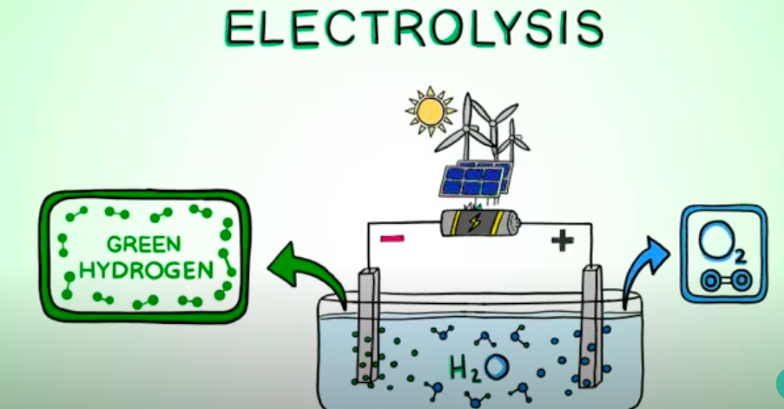

6 What are the two disadvantages of electrolysis?

It is expensive and time consuming.

7 What is a more common method of creating hydrogen gas?

By taking natural gas, made up of methane and other hydrocarbons, and a process called steam reforming.

Pair work: Work on one of the following tasks. Take notes, present your results to your partner.

1 Explain the COLOUR SPECTRUM of hydrogen in detail and draw a conclusion on environmentally-friendly technological solutions.
https://www.nationalgrid.com/stories/energy-explained/hydrogen-colour-spectrum (2022)

2 What is GOLDEN HYDROGEN?
https://www.goldhydrogen.com/ (2022)

