STB_TE Climate change and sustainability Pul

I Work in pairs and discuss:  What is your personal approach to “sustainability”? | 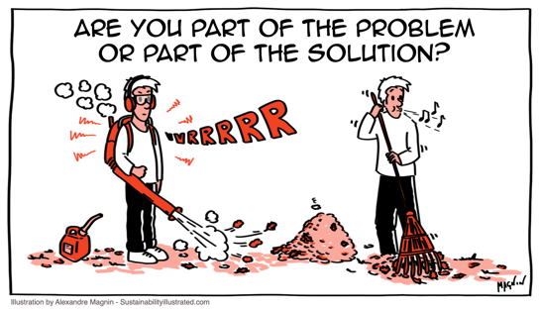  Source: https://sustainabilityillustrated.com/en/2019/04/23/human-power-is-best-cartoon/ (2022)

II Read the following text and answer the questions below.

What is sustainability?
The ecological definition of sustainability originated with the Brundtland Report in 1987, which describes sustainable development as one that satisfies the needs of the present without adversely affecting the conditions for future generations.
The report highlighted the interconnectedness of economic, social and ecological processes and was the foundation of the three-dimensional concept that was popularised at the 1992 earth Summit in Rio de Janeiro. This concept is based on the three connected dimensions of environment, society and economy. This expresses the following:
- Economic, social and ecological processes are interconnected. The actions of both public and private stakeholders cannot be considered as isolated, one-dimensional aspects; instead, one must consider the interrelationship between the three dimensions of environment, economy and society.
- Sustainable development means more than just environmental protection. To satisfy our material and immaterial needs, we need economic well-being and a society based on solidarity.
- The effects of today's actions on the future must be taken into account (intergenerational aspect) so that future generations can also satisfy their needs.
- Sustainable development requires a long-term structural change in our economic and social system, with the aim of reducing environmental and resource consumption to a sustainable level while maintaining economic performance and social cohesion.
Sources: Brundtland Report 1987, Federal Office for Spatial Development ARE https://de.myclimate.org/en/information/faq/faq-detail/what-is-sustainability/?etcc_med=SEA&etcc_par=Google&etcc_cmp=FAQs_EN&etcc_grp=124362385667&etcc_bky=what%20is%20sustainability&etcc_mty=b&etcc_plc=&etcc_ctv=517192898298&etcc_bde=c&etcc_var=Cj0KCQjw94WZBhDtARIsAKxWG-_E_5o7VM_nJr1XV-d_YrgqQXzM_F3db94KMlq4ebDV5Uxf8lYRbCUaAlAnEALw_wcB&gclid=Cj0KCQjw94WZBhDtARIsAKxWG-_E_5o7VM_nJr1XV-d_YrgqQXzM_F3db94KMlq4ebDV5Uxf8lYRbCUaAlAnEALw_wcB (2022)
III Answer the following questions.

1 What is a simple definition of sustainability?

2 What are the three principles of sustainability?

3 Why is sustainability so important?

4 How can we achieve sustainability?
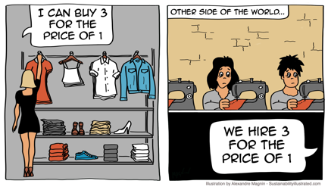 | IV Discuss the responsibility of the industrial countries in the context of climate change and sustainability.  Source: https://sustainabilityillustrated.com/en/2018/11/20/clothes-sustainable-fashion-cartoon/ (2022)

V Look at the 17 sustainable development goals of the UN from 2015. Decide which ones refer to social, ecological or environmental, and economical changes.

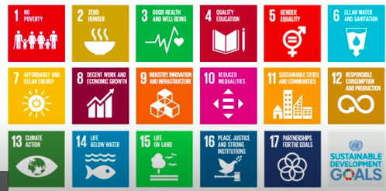
Source: https://www.globalcompact.de/en/our-work/sustainable-development-goals (2022)

Add the numbers  next to the  appropriate aspect: | 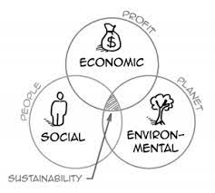  Source: https://sustainabilityillustrated.com/en/2020/02/19/sustainability-simple-definition/ (2022)

VI Discuss: Is it a well-balanced distribution in your opinion? Why/why not?

VII What is meant by the “wedding cake”? Watch this video to find out: https://youtu.be/qfOgdj4Okdw (2022)

VIII For checking the progress of each country in terms of SDGs, see
https://dashboards.sdgindex.org/map/goals/SDG1 (2022).

VI Look at the 17 sustainable development goals. Decide which ones refer to social, ecological, and economical changes.

social: 1, 2, 3, 4, 5, 7, 11, 16 => 8
ecological: 6, 13, 14, 15 => 4
economical: 8, 9, 10, 12, 17 => 5x

